

The bulletin 1/2

The 40th All Japan Orienteering Championship 2014
(IOF World Ranking Event / M21E & W21E)

Sunday, April 27, 2014

Official site: http://www.orienteering.com/joc2014/index-e.html

Venue: Sugadaira Kogen International Resort Centre

Address: 1223-1751 Sugadaira Kogen, Ueda city, Nagano prefecture, Japan
Google map: http://goo.gl/maps/SwWVy

Organiser: Japan Orienteering Association (JOA)
Kishi Memorial Hall, 1-1-1, Jinnan, Shibuya-ku, Tokyo, Japan
TEL: int +81-3-3467-4548 FAX: int +81-3-3467-4549
Contact person: Yuko Shimizu (shimizu@orienteering.or.jp)

WRE Event Advisor: IOF Event Adviser Toshio ONOYE (Japan)

Event Controller: Hideo OKANO (JOA)

Local Event Organiser: Nagano Prefecture Orienteering Association

Event Director: Keishi KIMURA (Nagano Orienteering Association)

Local Partner: Kanto Block Orienteering Liaison Group
Sugadaira Orienteering Club
Team Shirakaba

1. General information

[Event Schedule]
April 26, 2014 (Sat) 12:00-20:00 Registration
Sugadaira Kogen International Resort Centre

April 27, 2014 (Sun) 08:00-16:00 The 40th All Japan Orienteering Championship
Sugadaira Kogen International Resort Centre

07:00 Venue open
08:00-11:00 Transfer to Start area (10 minutes by bus: Depart every 30 minutes)
09:00 First start time
11:00 Start area closed
13:00-14:00 Medal Ceremony
14:00 Finish area closed
15:00 Venue close

[Location Map]
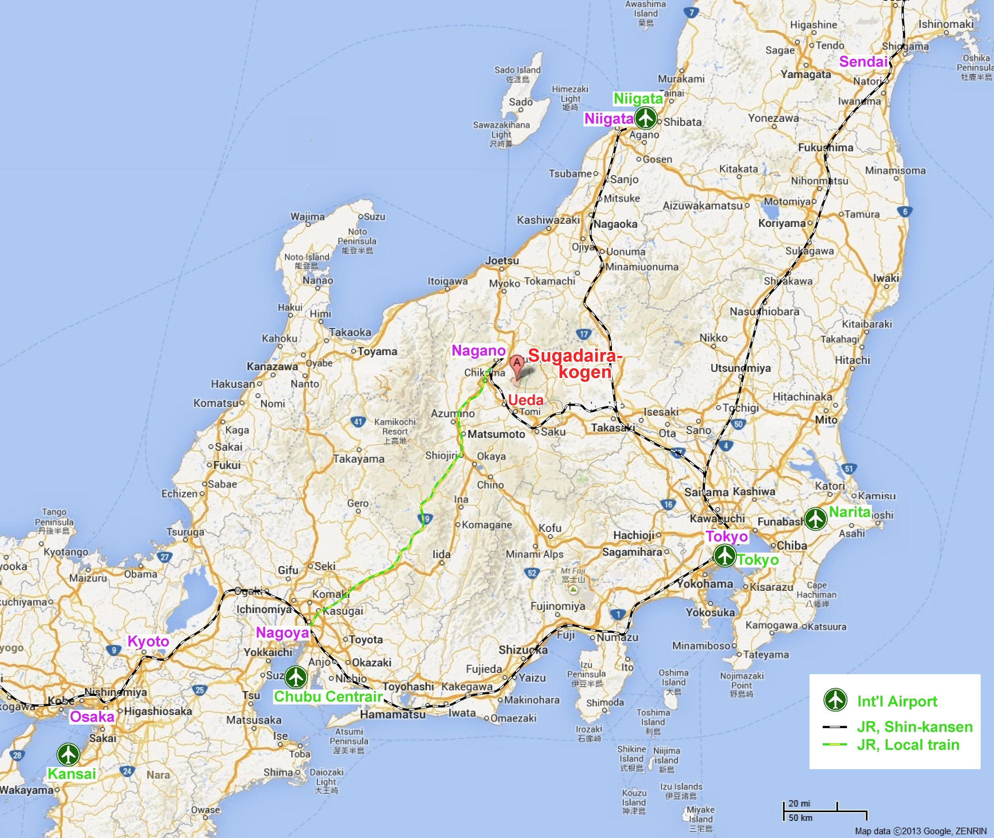

[Access to Sugadaira Kogen]
By Air & Train
Ueda Station (JR Nagano Shinkansen, Shinano Railway, and Ueda Dentetsu) is the nearest to Sugadaira Kogen. From Ueda Station, take Ueda bus to Sugadaira Kogen.

1. From Narita International Airport
Narita International Airport - Tokyo Station (Narita Express : 70 min.)
Tokyo Station - Ueda Station (Nagano Shinkansen: 100 min.)
Ueda Station – Sugadaira Kogen Bus stop (Ueda Bus: 60 min.)

2. From Haneda International Airport
Haneda International Airport - Tokyo Station (Train : 40 min.)
Tokyo Station - Ueda Station (Nagano Shinkansen: 100 min.)
Ueda Station – Sugadaira Kogen Bus stop (Ueda Bus: 60 min.)

3. From Chubu International Airport
Chubu International Airport - Nagoya Station (Train : 30 min.)
Nagoya Station - Nagano Station (Express Train Shinano: 180 min.)
Nagano Station - Ueda Station (Nagano Shinkansen: 15 min.)
Ueda Station – Sugadaira Kogen Bus stop (Ueda Bus: 60 min.)

4. From Kansai International Airport
Kansai International Airport – Shin Osaka Station (Express Train Haruka : 60 min.)
Shin Osaka Station - Nagoya Station (Tokaido Shinkansen: 60 min.)
Nagoya Station - Nagano Station (Express Train Shinano: 180 min.)
Nagano Station - Ueda Station (Nagano Shinkansen: 15 min.)
Ueda Station – Sugadaira Kogen Bus stop (Ueda Bus: 60 min.)

5. From Niigata International Airport
Niigata International Airport – Niigata Station (Airport Limousine: 60 min.)
Niigata Station - Ueda Station (Joetsu - Nagano Shinkansen: 110 min.)
Ueda Station – Sugadaira Kogen Bus stop (Ueda Bus: 60 min.)

By car
20 km from Ueda Sugadaira IC (Kanetsu/Joshinetsu Expressway): about 30 min.
25 km from Suzaka Naganohigashi IC (Chuo/Nagano Expressway): about 30 min.
2．Competition Information
[Classes]
World Ranking Event
Years of Age | Men | Winning Time | Women | Winning Time
No age restriction | M21E | 90 minutes | W21E | 75 minutes
Non-World Ranking Event
Years of Age | Men | Winning Time | Women | Winning Time
Born in 1994 or earlier  (Japanese only) | M20E | 70 minutes | W20E | 60 minutes
Born in 2004 or later | M10 | 20 minutes | W10 | 20 minutes
Born in 2002 or later | M12 | 30 minutes | W12 | 30 minutes
Born in 2001 or later | M15A | 50 minutes | W15A | 40 minutes
Born in 1996 or later | M18A | 60 minutes | W18A | 50 minutes
Born in 1994 or earlier | M20A | 70 minutes | W20A | 60 minutes
Born in 1995 or earlier | M21A | 80 minutes | W21A | 65 minutes
Born in 1993 or earlier | M21AS | 60 minutes | W21AS | 50 minutes
Born in 1979 or earlier | M35A | 70 minutes | W35A | 55 minutes
Born in 1974 or earlier | M40A | 65 minutes | W40A | 50 minutes
Born in 1969 or earlier | M45A | 60 minutes | W45A | 45 minutes
Born in 1964 or earlier | M50A | 55 minutes | W50A | 45 minutes
Born in 1959 or earlier | M55A | 50 minutes | W55A | 45 minutes
Born in 1954 or earlier | M60A | 50 minutes | W60A | 45 minutes
Born in 1949 or earlier | M65A | 50 minutes | W65A | 40 minutes
Born in 1944 or earlier | M70A | 45 minutes | W70A | 40 minutes
Born in 1939 or earlier | M75A | 90 minutes
Classes for less experienced  No age restriction | MBL  MBS | 50 minutes  30 minutes | WBL  WBS | 50 minutes  30 minutes
Note 1: Age as born on or after 1 January 2014
Note 2: Classes of 20A or older might be combined if not enough competitors apply (min. 5 participants per class)
Note 3: M21E/W21E are World Ranking Event. Participants may enter those classes individually but endorsement from their federation is required.

[Entry fees] *including SI rental fee
Class | Participation fee for each event except for sprint
Elite class | +24 yrs of age | 4,200 yen
Elite class | 19 - 23 yrs of age | 2,700 yen
Elite class | 18 yrs of age or younger | 2,200 yen
Non-Elite classes | +24 yrs of age | 3,700 yen
Non-Elite classes | 19 - 23 yrs of age | 2,700 yen
Non-Elite classes | 18 yrs of age or younger | 1,700 yen
[Competition rules]
The Competition Rules for IOF Foot Orienteering Events (Valid from 1 January 2014) and the Guidelines for World Ranking Events (WRE) (2012 Edition) are applied to the WRE event (M21E & W21E). To public classes (non WRE), the Competition Rules of JOA are applied.

[Embargoed area]
Competitors are not allowed to enter the area set in the map below until the event ends, for the purposes related to orienteering. Those who are not followed this restriction will be disqualified.
Please note that shops, restaurants, and accommodation in the embargoed area are accessible as an exception.

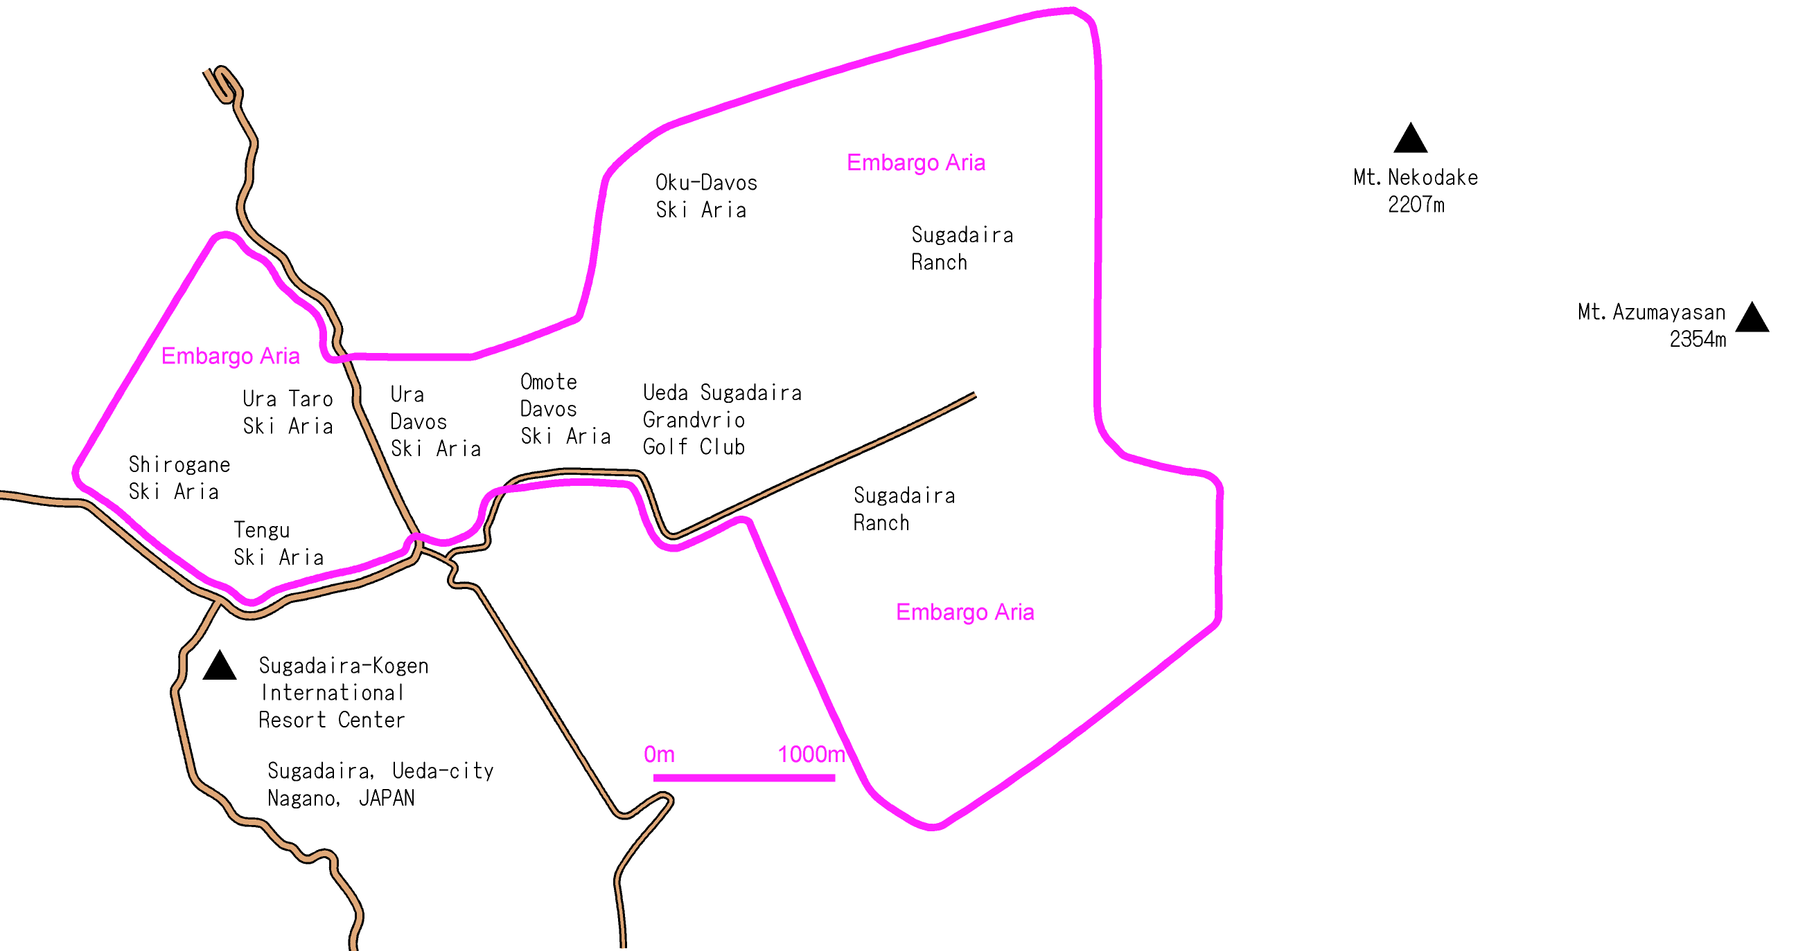

[Terrain profile]
This terrain is located in a subalpine zone, at altitudes between 1,700 and 1,280 meters above sea level. The oxygen level is 15% less than that of the sea level altitude, which influences prolonged athletic performance

Lots of farms, ski slopes, and cottage areas are seen in the terrain. Competitors may duck under barbed-wire fences when passing through the farms. The visibility is good when the weather is fine, but dense fogs frequently arise in this area. The level of difficulties will significantly depend on the weather of the event day.

Vegetation is mostly good, and competitors can run at high speed with enjoying a splendid view of the surrounding mountains. This terrain is perfectly ideal for long distance races.

In late April, normally snow can be seen only at the higher area of the train. However, there is still a possibility of snowfall or certain amount of deposited snow on the event day.
[Climate and weather]
AMEDAS Sugadaira Observatory (1253 m above sea level; 1km North West of the terrain)
Year | Rain (mm) | Highest Temp (°C) | Lowest Temp (°C) | Average  Temp (°C)
2008 | 0 | 11.8 | 0.3 | 5.4
2009 | 0 | 5.3 | -3.4 | 0.4
2010 | 9 | 6.2 | 1.2 | 2.9
2011 | 10 | 18.4 | 8.1 | 12.9
2012 | 2.5 | 9.4 | 2.8 | 6.0
2013 | 1.5 | 5.1 | -1.0 | 1.5

[Training opportunity]
No training opportunity will be offered for the event. Although a local event (Sugadaira Kogen Score Orienteering Event) will be held near the train on Saturday, April 26, the type of terrain and courses are different from the Championship event.

[Instruction for the wear]
There is no restriction of competition clothes and shoes. However, the organizer recommends full leg and arm cover clothing depending on the temperature and weather.

[Maps]
Orienteering Maps (JSOM 2007).
Map scale for WRE class is 1:15,000 and contour interval will be 5 m. 1:10,000 map scale may be used for non-WRE classes. Maps will be printed by ink jet printers, enclosed within a plastic bag.

[Existing maps]
Sugadaira Kogen (1996): Scale 1:15,000
Nippon Davos (2002): Scale 1:10,000
Sugadaira Bokujyo (2009): Scale 1:10,000

[Control description]
IOF Control description

[Punching system]
SPORTident (SI) system is used in all classes.

[Drug Policy]
The IOF Anti-Doping Rules apply to the WRE event. Competitors who are asked by the event officials at the finish area shall follow their instructions.
3. Entry procedure

Entry closing date: Monday, March 17, 2014

[General Entry Procedures]
Entries can be made through e-mail or surface mail. Please note that entries are confirmed only after the entry fee is paid.

1) e-mail
Download the entry form from our web site, fill the form and send to the organizer by e-mail (shimizu@orienteering.or.jp)
The organizer will send you back an e-mail confirmation when the entry form is received. In case you do not receive our reply in a couple of days, please let the organizer know by e-mail or fax.

2) Surface mail
Fill the entry form attached with this bulletin and post it to:
Japan Orienteering Association
Kishi Memorial Hall, 1-1-1, Jinnan, Shibuya-ku, Tokyo, Japan

[Entry for the Elite class]
Competitors in WRE classes can be registered individually or through their clubs but should be endorsed by their federation. The federation should provide the list of the WRE class runners.

[Payment]
All payments should be made by international bank transfer to JOA's bank account.
To cover bank charges, please add 4,000 yen on each transfer. In case any additional charges occur, the organiser would pass on the charges to the participant on arrival.

JOA bank account details
Bank Name: SUMITOMO MITSUI BANKING CORPORATION
Branch: Shibuya branch(Branch code: 654)
Branch address:20-2, Udagawacho, Shibuya-ku, Tokyo, 150-0042, Japan
Account Number: 8399155
Account Name: Japan Orienteering Association
SWIFT Code: SMBCJPJT

4. Accommodation information
The organiser arranges official accommodation to competitors. It is highly recommended to stay one of the official accommodation to join the event more smoothly. Closing date for accommodation booking is Monday, April 14, 2014. Please contact shimizu@orienteering.or.jp for booking and more information

[Accommodation fee] per person per night
Adult: 7,300 yen per night (Shared room, including dinner and breakfast)
Children (under 12 yrs old): 5,110 yen per night (Shared room, including dinner and breakfast)
*Official bus runs from the official accommodation to the start area.

4. Other information
[Visa]
If you are from the following countries, you need a visa to visit Japan.
BELARUS, BRAZIL, CHILE, CHINA, COLOMBIA, REPUBLIC OF MOLDOVA, MONGOLIA, D.P.R. KOREA, ROMANIA, SOUTH AFRICA, RUSSIA, UKRAINE.
Please ask your nearest Japanese Embassy for further details or visit following URL for latest information. http://www.mofa.go.jp/j_info/visit/visa/

For necessary document for the Visa, please contact JOA secretary by e-mail (shimizu@orienteering.or.jp). Those who require visa document should notice this in entry form and bear expense of 2,000 yen + EMS postage (900 –1,500 yen).

[Insurance]
All participants are strongly recommended to buy a medical and accident insurance policy in their own country. The organizer will sign up a sport group accident insurance, but this insurance is only valid for medical treatment in Japan.

The 40th All Japan Orienteering Championship 2014
Entry Form
Contact details
Contact Name |  | Federation / Country
Address
Telephone |  | Fax
E-mail |  | Club

Participant details
Family Name | Given Name | Federation  / Club | Gender | Date of  Birth | Age | Class | WRE ID  (WRE class only) | Total fees  (yen)
Example | Japan | Japan OC | M | 01/03/1960 | 49 | M40 | N/A | 3,700

[Entry fees] *including SI rental fee
Class | Participation fee for each event except for sprint
Elite class | +24 yrs of age | 4,200 yen
Elite class | 19 - 23 yrs of age | 2,700 yen
Elite class | 18 yrs of age or younger | 2,200 yen
Non-Elite classes | +24 yrs of age | 3,700 yen
Non-Elite classes | 19 - 23 yrs of age | 2,700 yen
Non-Elite classes | 18 yrs of age or younger | 1,700 yen

